|  |  |  |  |  |  |
| --- | --- | --- | --- | --- | --- |
| Description | Current | Change | Recommended | Allocation | ICR |
| BT Panorama Super | | | | | |
| Investment number two | $15,000 | $15,000 | $0 | 30.00% | 0.00% |
| Investment number one | $12,500 | $12,500 | $0 | 25.00% | 1.50% |
| Investment number two | $21,500 | $21,500 | $0 | 43.00% | 0.00% |
| Investment number four | $1,000 | $1,000 | $0 | 2.00% | 0.00% |
| BT Panorama Super | $50,000 | $50,000 | $0 |  |  |
| BT Panorama Super | | | | | |
| Investment number two | $0 | $30,000 | $30,000 | 46.15% | 0.00% |
| Investment number one | $0 | $25,000 | $25,000 | 38.46% | 1.50% |
| Investment number one | $0 | $10,000 | $10,000 | 15.38% | 1.50% |
| BT Panorama Super | $0 | $65,000 | $65,000 |  |  |
| Total | $50,000 | $115,000 | $65,000 |  |  |

|  |  |  |
| --- | --- | --- |
| Status | Current | Recommended |
| Description | BT Panorama Super | BT Panorama Super |
| Balance | $50,000 | $65,000 |
| One-off Fees Subheader |  |  |
| Ongoing Fees Subheader | | |
| - Sliding Admin Fee | $75.00 (0.15%) | $97.50 (0.15%) |
| - Admin Fee (Flat) | $480.00 | $480.00 |
| Subtotal | $75.00 | $97.50 |
| Adviser Fee (Flat) | None | None |
| Total | $75.00 (0.15%) | $97.50 (0.15%) |
| Comparative Total | $75.00 | $97.50 |

|  |  |  |
| --- | --- | --- |
| - Consol Balance | $65,000 | $65,000 |
| Adviser Fee (Flat) | None | None |

|  |  |  |  |
| --- | --- | --- | --- |
| Status | Current | Risk Profile | Variance |
| Defensive | | | |
| Cash | 14.60% | 0.00% | 14.60% |
| Australian Fixed Interest | 0.99% | 49.00% | -48.01% |
| International Fixed Interest | 0.99% | 0% | 0.99% |
| Subtotal | 16.58% | 49.00% | -32.42% |
| Growth Subheader | | | |
| Australian Equities | 70.90% | 51.00% | 19.90% |
| International Equities | 12.52% | 1.00% | 11.52% |
| Australian Listed Property | 0% | 0% | 0% |
| International Listed Property | 0% | 0% | 0% |
| Direct Property | 0% | 0% | 0% |
| Growth Subtotal | 83.42% | 52.00% | 31.42% |
| Alternative Subheader | | | |
| Alternatives | 0% | 0% | 0% |
| Alternative Subtotal | 0% | 0% | 0% |
| Total | 100.00% | 100.00% | 100.00% |

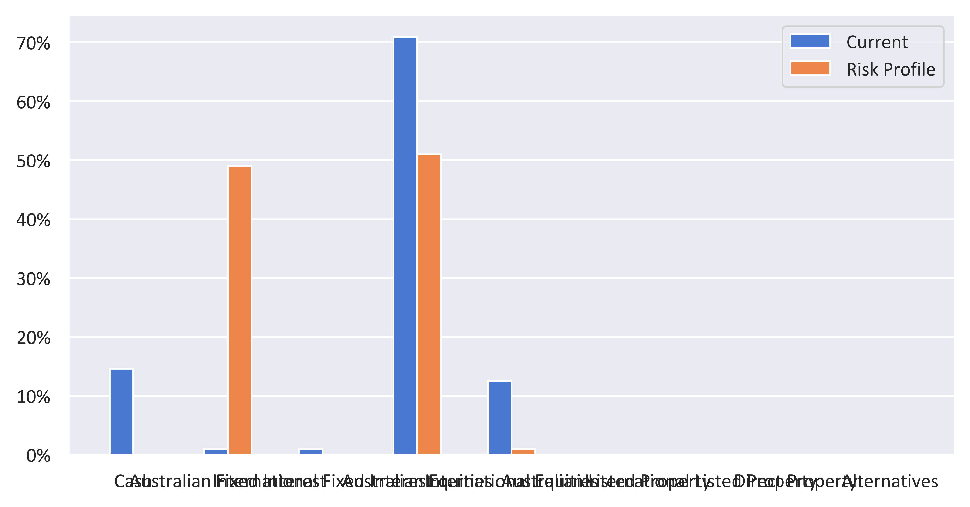

|  |  |  |  |
| --- | --- | --- | --- |
| Status | Recommended | Risk Profile | Variance |
| Defensive | | | |
| Cash | 9.23% | 0.00% | 9.23% |
| Australian Fixed Interest | 0% | 49.00% | -49.00% |
| International Fixed Interest | 0% | 0% | 0% |
| Subtotal | 9.23% | 49.00% | -39.77% |
| Growth Subheader | | | |
| Australian Equities | 63.85% | 51.00% | 12.85% |
| International Equities | 26.92% | 1.00% | 25.92% |
| Australian Listed Property | 0% | 0% | 0% |
| International Listed Property | 0% | 0% | 0% |
| Direct Property | 0% | 0% | 0% |
| Growth Subtotal | 90.77% | 52.00% | 38.77% |
| Alternative Subheader | | | |
| Alternatives | 0% | 0% | 0% |
| Alternative Subtotal | 0% | 0% | 0% |
| Total | 100.00% | 100.00% | 100.00% |

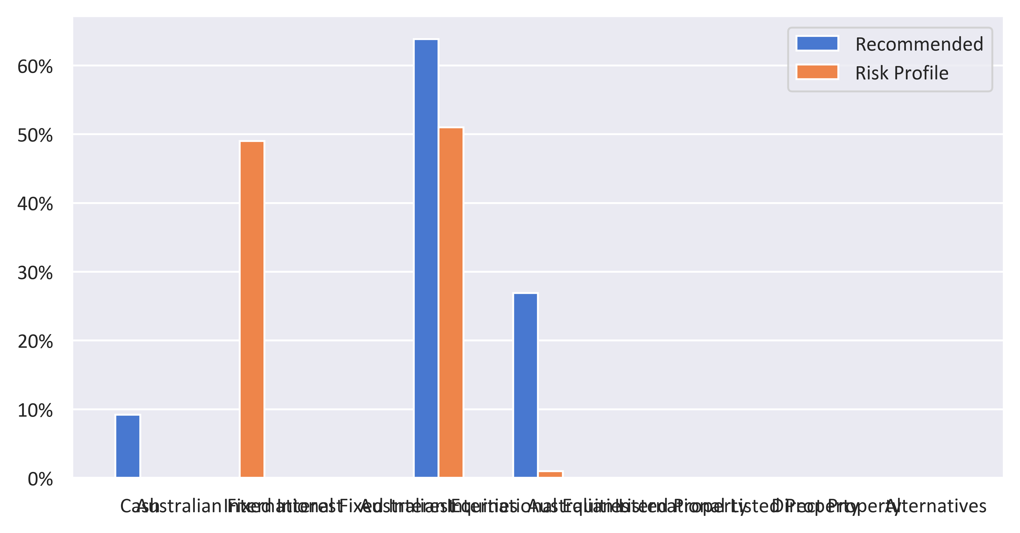

|  |  |  |  |  |
| --- | --- | --- | --- | --- |
| Status | Current | Risk Profile | Recommended | Variance |
| Defensive | | | | |
| Cash | 14.60% | 0.00% | 9.23% | 9.23% |
| Australian Fixed Interest | 0.99% | 49.00% | 0% | -49.00% |
| International Fixed Interest | 0.99% | 0% | 0% | 0% |
| Subtotal | 16.58% | 49.00% | 9.23% | -39.77% |
| Growth Subheader | | | | |
| Australian Equities | 70.90% | 51.00% | 63.85% | 12.85% |
| International Equities | 12.52% | 1.00% | 26.92% | 25.92% |
| Australian Listed Property | 0% | 0% | 0% | 0% |
| International Listed Property | 0% | 0% | 0% | 0% |
| Direct Property | 0% | 0% | 0% | 0% |
| Growth Subtotal | 83.42% | 52.00% | 90.77% | 38.77% |
| Alternative Subheader | | | | |
| Alternatives | 0% | 0% | 0% | 0% |
| Alternative Subtotal | 0% | 0% | 0% | 0% |
| Total | 100.00% | 100.00% | 100.00% | 0.00% |

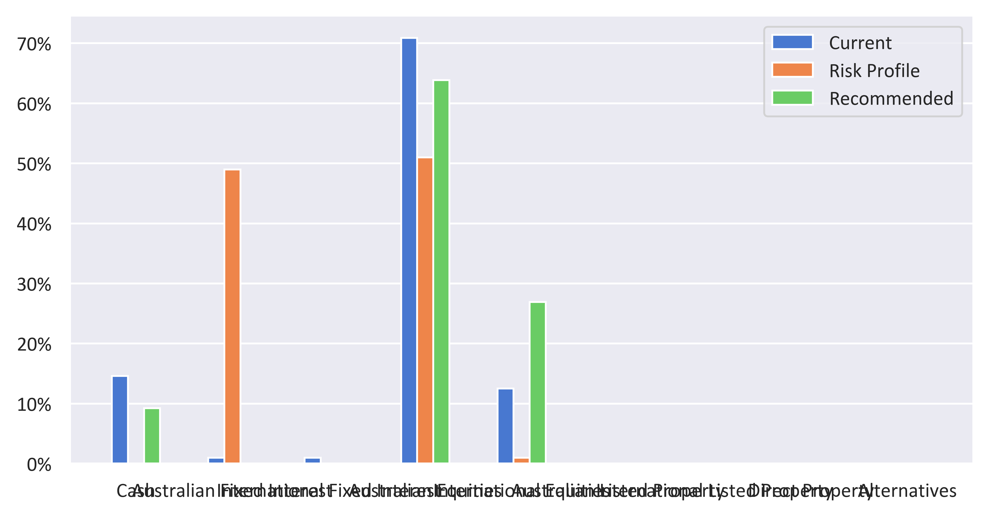

|  |  |  |  |
| --- | --- | --- | --- |
| Status | Current | Recommended | Variance |
| Defensive | | | |
| Cash | 14.60% | 9.23% | -5.37% |
| Australian Fixed Interest | 0.99% | 0% | -0.99% |
| International Fixed Interest | 0.99% | 0% | -0.99% |
| Subtotal | 16.58% | 9.23% | -7.35% |
| Growth Subheader | | | |
| Australian Equities | 70.90% | 63.85% | -7.05% |
| International Equities | 12.52% | 26.92% | 14.40% |
| Australian Listed Property | 0% | 0% | 0% |
| International Listed Property | 0% | 0% | 0% |
| Direct Property | 0% | 0% | 0% |
| Growth Subtotal | 83.42% | 90.77% | 7.35% |
| Alternative Subheader | | | |
| Alternatives | 0% | 0% | 0% |
| Alternative Subtotal | 0% | 0% | 0% |
| Total | 100.00% | 100.00% | 100.00% |

